Access Fund Grant Application
* required fields

I. GENERAL INFORMATION

Applicant’s Organization/Group Name* | Western Mass Climbers’ Coalition
Address* | 25 Parkview Drive
City* | South Hadley
State* | MA
Zip Code* | 01075
Telephone Number* | 413-493-1974
Contact Person’s First Name* | Jeff
Contact Person’s Last Name* | Squire
Contact Person’s Title* | President
Director (if different from Contact Person)* | Peter Clark
Email Address* | wmcc@climbgneiss.org
Grant Amount Request* | $4,000
Project Name* | Farley parking improvements
Period Grant will Cover* | Paved driveway entry
Earliest Grant Funds Release Date* | 5/2014
Latest Grant Funds Release Date* | 11/2014
Have you applied to the Access Fund for a grant before? | Yes No
If Yes, give year and name of project. | Farley preservation initiative
Are you a 501(c)(3) organization?* | Yes No
EIN (If Applicable) | 81-
If you have a fiscal sponsor instead of your own 501(c)(3), please provide the following:
Fiscal Sponsor
Contact Person/Title
Fiscal Sponsor Phone Number
Fiscal Sponsor Email

Type of grant request*:
Educational Outreach: Brochures, Kiosks, etc. |  | Climbing Area Facilities/Improvements
Grassroots Activism: Start-Up Costs |  | Land Acquisition
Other:

Description how Access Fund Grant Criteria is met*
(please provide a brief description of 50 words or less for all applicable criterion)
Is action-oriented:
This proactive maintenance project renews public interest and commitment to good land management practices and will also be part of a local Adopt-A-Crag event sponsored by the WMCC.
Builds local climber involvement and support:
This project will demonstrate the WMCC’s commitment to Farley Ledge and putting membership dollars to work.
Is strategic and forward-looking in its targeting and goals:
This project will represent a tangible and visible improvement at an area managed by the WMCC during a time of limited activity for the organization. This highly visible project seeks to bolster our membership base and visibility.
Accomplishes specific goals and objects that can be effectively measured:
The goal of managing Farley Ledge for environmental and recreational values will be supported by this project as it will greatly improve current erosion concerns.
Encourages access or enhances opportunities for climbing:
Improving and stabilizing the steep driveway into the parking lot will improve the visitor experience over the currently eroded and rutted gravel drive introduction to Farley Ledge.
Develops knowledge about natural and cultural resource values where the information is used to open climbing areas or mitigate climbing impacts:
The WMCC actively promotes the protection of valuable natural resources to further improve access to local climbing areas. This is particularly evident with WMCC efforts at Farley Ledge.
Reduces climber impacts on natural and cultural resources within the climbing community:
Improving and hardening the frequently used driveway will avoid recurring erosion and impacts to adjacent wetlands at a time when visitor numbers continue to increase.
Raises awareness about climber responsibility toward conserving the climbing environment:
The WMCC is acting proactively to resolve potential erosion and access issues to demonstrate responsible stewardship resource management practices.
Supported by the climbing community:
The local climbing community and WMCC membership has demonstrated support of this project.
Utilizes matching agency or local funds (ideally this will be at least 50%):
In addition to potential grant money, the project budget is supported by funds provided by the WMCC specifically for this project.
Incorporates a degree of volunteer labor and/or pro bono services:
Project coordination, prep work and final cleanup will be the responsibility of the WMCC in the form of an organized Adopt-A-Crag event.
Project area in the United States:
Project is located in Erving, Massachusetts.

The project is on*:
(please provide evidence of land owner/manager permission if applicable—see Sec. VIII)
National Park |  | State Forest/Park
City/Town Park |  | National Forest
Private Land |  | BLM Property
Other: |  | Not Applicable

II. ORGANIZATION/AGENCY INFORMATION
Mission statement, brief statement of organization’s history, goals, and/or objectives. We want to know who you are, what you've accomplished, what your mission is, what your goals are and how you plan to achieve them (250 word limit):

The WMCC’s mission is a local 501(c)(3) non-profit volunteer climbers' organization that works to build cohesive relationships with advocacy groups, state and local governments, landowners, and conservation groups to keep climbing areas open and conserve the climbing environment in Western Massachusetts. Founded in 2002, the WMCC has worked to secure access to the most significant climbing areas in western MA including Farley Ledge, which has grown to be the most valuable climbing area in southern New England. We have raised more than $100,000 since our inception to further our efforts of land protection, acquisition and resource management. The WMCC continues to improve our relationship with landowners for secured access and to expand our supporting membership.

III. PROJECT DESCRIPTION
A. Summary of the project (100 word limit) – Please edit carefully – this summary, along with one representative photo, will be shared online with Access Fund members to rate the project, assisting the Access Fund Grant Committee to determine final funding approval:

In 2007, the WMCC purchased property at the base of Farley Ledge to help protect against potential development and to construct a public parking lot to provide access to the cliff and trail system. Farley’s popularity has continued to grow since this initial effort and it has become necessary to improve portions of the current parking lot to alleviate concerns about erosion, rutting and occasional inaccessibility. This grant request would fund paving the existing steep, gravel driveway to ensure a more sustainable and durable site demonstrating a proactive resource management and improvement initiative.

B. Brief statement of problem to be addressed (250 word limit):

The existing gravel driveway to the Farley Ledge parking lot climbs a short, steep hill directly off a major state highway. Both visiting climbers and the general public coming to sample some Farley’s scenic trail network and great rock use this driveway as the primary means of access. Heavy rains, continued use combined with a steep grade has resulted in a driveway that is uneven and deeply rutted occasionally cutting off access to smaller vehicles, despite several attempts to remedy the problem(s). It has been determined that paving the initial 30’ of driveway would provide a more stable and sustainable site entry.
C. Please provide description of your proposal that includes the overall goal of the project and a brief explanation of how you would use Access Fund’s grant monies (500 word limit):

The overall goal of this project is to install a stabilized paved driveway entrance to the public parking lot at Farley Ledge. All of the monies received from the Access Fund would directly fund this project.
IV. BUDGET
A. Itemize Expenses:
Item | Cost
Driveway paving, including:  - Grading  - Leveling  - Erosion curb  - Paving | $4,000

TOTAL COST (A) | $4,000

B. MATCHING FUNDS AVAILABLE FOR PROGRAM:

Gifts & Grants (pledged or paid)
Trustees
Corporations
Foundations
Individuals
Government
Other (special events, membership) | $1,000

TOTAL FUNDS AVAILABLE (B) | $1,000

BALANCE REQUIRED (A minus B) | $3,000

AMOUNT REQUESTED | $3,000

V. PARTNERSHIPS
A. Please list all organizations participating in planning or contributing to the project, including land managers, retailers and business partners, and other non-profit organizations.
Org #1: | Western Mass Climbers’ Coalition
Contact: | Jeff Squire
Address: | 25 Parkview Drive South Hadley, MA 01075
Email: | wmcc@climbgneiss.org
Phone: | 413-493-1974

Org #2:
Contact:
Address:
Email:
Phone:

B. The Access Fund is committed to giving back to the community that supports our work. In order to assure that we are supporting projects that are important to our members, the Access Fund gives preference to applications from organizations that have active Access Fund members involved. For organizations whose mission is not directly tied to protecting climbing access (for instance USFS, BLM, etc), we only ask that the project directly supports a valued climbing area.

What has your organization done to support the Access Fund and what do you plan to do? (150 word limit)

The WMCC continues to work closely with the Access Fund to ensure the efforts of the WMCC reflect current best management practices, knowledge and resources. The WMCC maintains a strong partnership with the Access Fund through the joint membership program and through the WMCC’s continued involvement in Access Fund sponsored events, retreats, and workshops.

If you or anyone from your local climbing community are interested in becoming an Access Fund member, click here.

VI. ADDITIONAL NOTES/COMMENTS/SPECIAL REQUESTS (150 word limit)

VII. EVALUATION MEASURES
Please describe expected results during the funding period and how you will define and measure success (150 word limit)

Measurable results will be observable following the paving of the driveway in the form of reduced erosion and maintenance effort.

VIII. ATTACHMENTS (PDF, Word, and JPG formats are preferred)
A. One representative photo (JPG) of the property or proposed project area to share with Access Fund members to rate the project.
B. Please attach a statement or letter of approval from the landowner/manager for projects that involve construction or improvements to facilities, trails, signage, or parking areas. Review grant guidelines for examples here.
C. For grant requests over $5,000.00 please include the following:
Proof of 501(c)(3) tax-exempt status with your letter
Organization’s most recent financial statement

Organization’s most recent 990 form

Organization’s most recent W9 form

Organization’s bylaws

Organization’s articles of incorporation

Organization’s list of current board of directors

C. If you have a fiscal sponsor, you will need to include the following:

The fiscal sponsor’s 501(c)(3) tax-exempt letter

Consent letter from the fiscal sponsor

D. For land acquisitions, please review grant guidelines here. If the property is already under contract, please attach the fully executed purchase or option agreement.

E. Attach any other relevant maps and/or photos (optional)

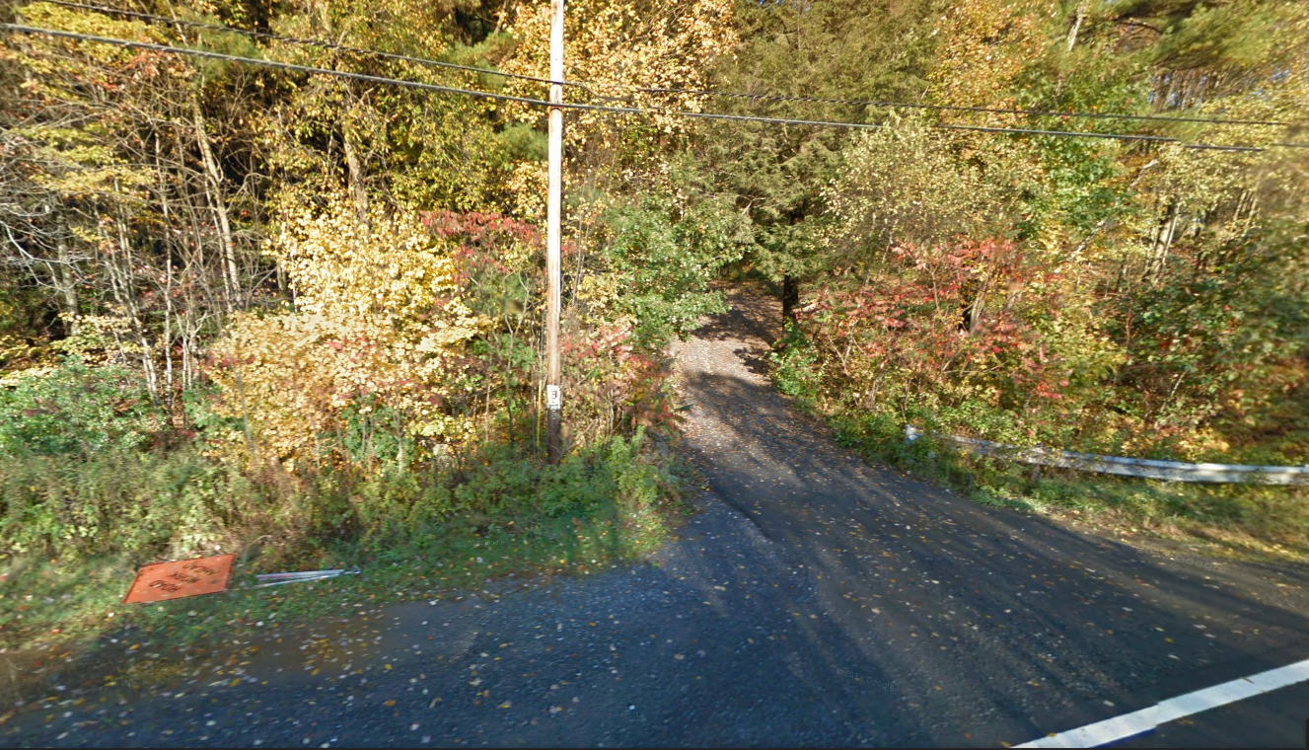
View of the current driveway to the Farley Ledge parking lot from the highway. The lower portion of the drive to the utility pole was paved during the initial construction of the parking lot. The remaining 30 of driveway slopes steeply uphill and is composed of compacted gravel which continues to wash out during heavy rain events depositing sediment in the wetlands on either side. Ruts and channelized water grooves also make vehicular access up the drive difficult.

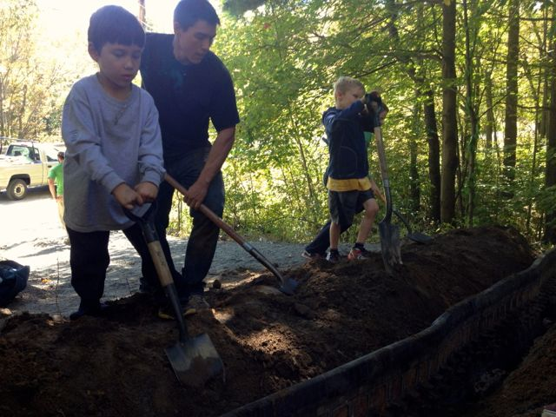
Previous Adopt-A-Crag events, such as this one in October of 2013, have sought to improve the driveway be regrading and installing measures which would potentially reduce erosion concerns such as this water bar.
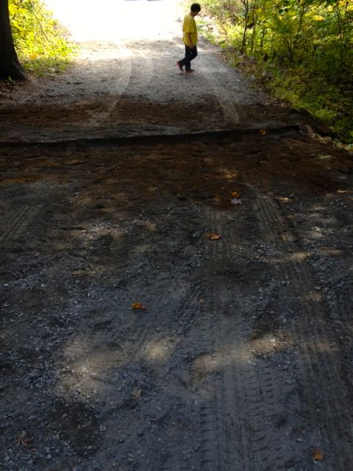
View looking down the driveway following the 2013 Adopt-A-Crag event. The improvements, while beneficial, have not resulted in a long term solution that withstand the increasing visitor numbers and extreme weather fluctuations we have experienced in the northeast.

